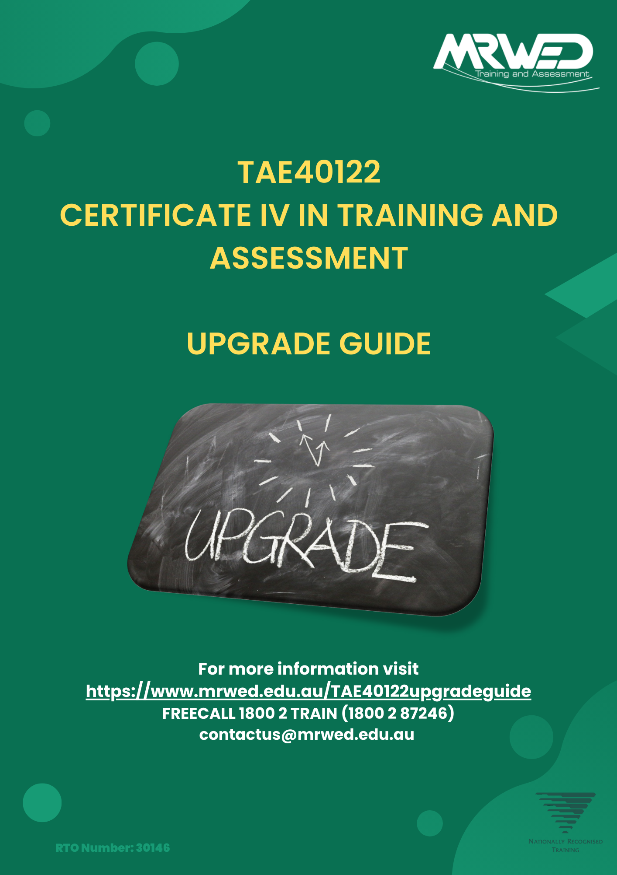

Contents
Welcome Message 3
Process 4
TAE40122 Certificate IV in Training and Assessment packaging rules 5
Upgrading from TAE40116 Certificate IV in Training and Assessment 6
Upgrading from TAE40110 Certificate IV in Training and Assessment 7
Upgrading from previous Skill Sets 7
Pricing 8
Frequently Asked Questions 9
Mapping 10
Documentary Evidence Summary 11
Copy of TAE40116 Certificate IV in Training and Assessment 11
Current resume that includes training and assessment experience 11
Unit of Competency evidence guidance: 11
TAEDES411 Use nationally recognised training products to meet vocational training needs. 11
TAEDES412 Design and develop plans for vocational training. 12
TAEASS412 Assess competence. 12
TAEASS413 Participate in assessment validation. 13
TAEASS512 Design and develop assessment tools. 13
TAEDEL411 Facilitate vocational training. 14
TAELLN421 Integrate core skills support into training and assessment. 14
Knowledge Evidence Quiz 15
TAEDES411 Use nationally recognised training products to meet vocational training needs. 15
TAEDES412 Design and develop plans for vocational training. 16
TAEASS412 Assess competence. 17
TAEASS413 Participate in assessment validation. 18
TAEASS512 Design and develop assessment tools. 19
TAEDEL411 Facilitate vocational training. 20
TAELLN421 Integrate core skills support into training and assessment. 21

Welcome Message
This TAE40122 UPGRADE GUIDE provides a pathway for candidates who want to upgrade from a previous version of the Certificate IV in Training and Assessment or TAE Skill set to the current TAE40122 Certificate IV in Training and Assessment.
This is a “recognition” pathway based on the compilation of evidence. This process is designed for currently qualified and experienced trainers and assessors. We appreciate that gathering quality evidence and portfolio preparation takes time. MRWED will give you up to 3 months after your application date to submit your evidence.
The MRWED Learning Leader is looking for currency of competence so use recent projects as evidence. As a rule of thumb, evidence from the last two years is preferable and evidence that is more than five years old is of limited value.
To have skills formally recognised in the national system, our assessors must make sure you have the skills and knowledge to meet the industry standard. This means you must be involved in a careful and comprehensive process that covers the content of all unit/s or qualification/s you can be recognised for.
Whilst the TAE40116 Certificate IV in Training and Assessment and the TAE40122 Certificate IV in Training and Assessment have been deemed equivalent in outcome, many of the units of competency from the version 5.0 of the Training Package have had significant changes that require additional evidence to be collected.

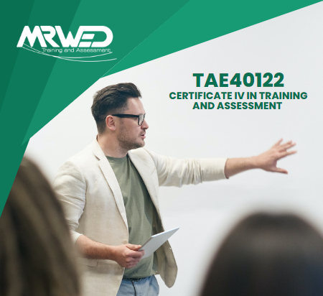

Process
The MRWED Team are ready to help you through the steps required to complete your studies.
Step 1 – Application.
Submit your application, provide a copy of your current training and assessment qualifications and pay the application fee of $249 - https://www.mrwed.edu.au/apply-now/
Step 2 – Confirmation and Learning Journey.
The MRWED Team will verify your certificates and review the units of competency provided that can be used in your upgrade application. A MRWED Team member will then contact you with a recommended Learning Journey and final price.
Step 3 – Create a portfolio of evidence.
Your Learning Journey will confirm what evidence you will need to provide. The most important part of the evidence collection for RPL will be to provide a portfolio of documentary evidence. A list of indicative evidence will be identified later in this Upgrade Guide. MRWED will provide you with access to a shared evidence folder on MRWED’s corporate Dropbox account. Upload the required evidence into the shared evidence folder, ensuring that your evidence matches up clearly with the requested criteria.
Step 4 – Complete the knowledge assessments.
Complete the series of knowledge assessment questions provided for each unit included in your Learning Journey. These questions are designed to target the specific changes in the units being upgraded. There is no specific word count required for your responses, but they must be detailed enough to demonstrate your competency.
Step 5 – Review of evidence.
A MRWED Learning Leader will review the evidence provided, (including your responses to the knowledge assessments) and will commence the process of matching your skills and knowledge to the requirements of the relevant Units of Competency. At this point, they may contact you to schedule a conversation, so that you can further explain the details of your training and assessment experience.
Step 6 – Practical demonstration of your skills.
The MRWED Learning Leader may elect to conduct an additional practical skills test, targeting any gaps in your portfolio of evidence that may be identified. This will provide an opportunity for you to demonstrate your level of competence for the required skills.
Step 7 – Other evidence sources (when required).
Sometimes you or the assessor may identify other relevant sources of evidence that can help to substantiate your competency. Please be assured that our assessors will not hesitate to consider alternative evidence, provided it is valid, current, and authentic, and contributes to you providing sufficient evidence to be granted RPL.

TAE40122 Certificate IV in Training and Assessment packaging rules
Total number of units = 12
6 core units:
- TAEASS412 Assess competence
- TAEASS413 Participate in assessment validation
- TAEDEL411 Facilitate vocational training
- TAEDES411 Use nationally recognised training products to meet vocational training needs
- TAEDES412 Design and develop plans for vocational training
- TAEPDD401 Work effectively in the VET sector
6 elective units, of which:
- at least 3 must be from Group A
of the remaining elective units:
- all may be from the elective units listed in the qualification packaging rules.
- up to 2 may be from any currently endorsed Certificate III or above training package qualification or accredited course, provided that no more than 1 is selected from a Certificate III level.

Elective units chosen must be relevant to the work environment and the qualification, maintain the integrity of the AQF alignment, not duplicate the outcome of another unit chosen for the qualification, and contribute to a valid vocational outcome for entry-level VET teachers, trainers, and assessors.

The MRWED Team

Upgrading from TAE40116 Certificate IV in Training and Assessment
Once your TAE40116 Certificate IV in Training and Assessment certification has been verified, you will receive 1 credit transfer (CT), namely:
- TAEDEL412 Facilitate workplace-based learning (Elective Group A)
By providing your TAE40116 transcript and then all the required documentary evidence and successfully completing the knowledge evidence quiz you can obtain Recognition of Prior Learning (RPL) for up to 7 units of competency, as follows:
- TAEASS412 Assess competence (Core)
- TAEASS413 Participate in assessment validation (Core)
- TAEDEL411 Facilitate vocational training (Core)
- TAEDES411 Use nationally recognised training products to meet vocational training needs (Core)
- TAEDES412 Design and develop plans for vocational training (Core)
- TAELLN421 Integrate core skills support into training and assessment (Elective group B)
- TAEASS512 Design and develop assessment tools (Elective Group A)
In most cases, an additional unit of competency from the TAE40116 will be available for Credit Transfer. If you also hold the TAE40110 Certificate IV in Training and Assessment, additional elective credit transfers may be available.
A MRWED Learning Leader will confirm this with you after reviewing your available transcripts by providing a personalised Learning Journey to you.
To meet the packaging rules for the TAE40122 Certificate IV in Training and Assessment you will need to gain the core unit “TAEPDD401 Work effectively in the VET sector” along with 3 Elective units. At least one of these must be from Elective Group A. These may be completed via RPL, CT or a training and assessment pathway.
- TAEDEL311 Provide work skill instruction (Elective Group A)
- TAEDEL414 Mentor in the workplace (Elective Group A)
- TAEDEL405 Plan, organise and facilitate online learning (Elective Group A)
- TAEASS404 Assess competence in an online environment (Elective Group A)
- TAEDEL413 Facilitate distance-based training (Elective Group A)
- BSBAUD412 Work within compliance frameworks (Elective Group C)
- BSBHRM413 Support the learning and development of teams and individuals (Elective Group C)
- BSBCMM411 Make presentations (Imported Elective)

Upgrading from TAE40110 Certificate IV in Training and Assessment
Once your TAE40110 Certificate IV in Training and Assessment certification has been verified, you will receive 1 credit transfer (CT), namely:
- TAEDEL412 Facilitate workplace-based learning (Elective Group A)
By providing your TAE40110 transcript and then all the required documentary evidence and successfully completing the knowledge evidence quiz you can obtain Recognition of Prior Learning (RPL) for up to 5 units of competency, as follows:
- TAEASS412 Assess competence (Core)
- TAEASS413 Participate in assessment validation (Core)
- TAEDEL411 Facilitate vocational training (Core)
- TAEDES411 Use nationally recognised training products to meet vocational training needs (Core)
- TAEDES412 Design and develop plans for vocational training (Core)
In most cases, other elective units of competency from the TAE40110 will be available for Credit Transfer. A MRWED Learning Leader will confirm this in your Learning Journey after reviewing your available transcripts.
To meet the packaging rules for the TAE40122 Certificate IV in Training and Assessment you will need to gain the core unit “TAEPDD401 Work effectively in the VET sector” along with 5 additional Elective units. At least 2 of these must be from Elective Group A as per the below list. These may be completed via RPL, CT or a training and assessment pathway.
- TAEDEL311 Provide work skill instruction (Elective Group A)
- TAEDEL414 Mentor in the workplace (Elective Group A)
- TAEDEL405 Plan, organise and facilitate online learning (Elective Group A)
- TAEASS404 Assess competence in an online environment (Elective Group A)
- TAEDEL413 Facilitate distance-based training (Elective Group A)
- TAEASS512 Design and develop assessment tools (Elective Group A)
- BSBAUD412 Work within compliance frameworks (Elective Group C)
- BSBHRM413 Support the learning and development of teams and individuals (Elective Group C)
- BSBCMM411 Make presentations (Imported Elective)
- TAELLN421 Integrate core skills support into training and assessment (Elective group B)

Upgrading from previous Skill Sets
A MRWED Learning Leader will review the Statements of Attainment supplied to provide you with a personalised journey that takes into consideration the units previously achieved.
As there are many possible units across the Skill Set range, the MRWED Learning Leader will review these at a unit-by-unit level.

Pricing
Upon application you will be required to pay a $249.00 non-refundable application fee. Payment of this fee is required to begin the assessment of your application and the creation of your personalised Learning Journey. The $249.00 application fee will be deducted from the total course cost.
MRWED graduates that have previously completed the TAE40110 -> TAE40116 Upgrade with MRWED will receive an additional $199.00 off their final course cost. This offer is exclusively for returning upgrade graduates and will be automatically applied if the MRWED Learning Leader assessing your application verifies that you have previously completed the TAE40110 -> TAE40116 upgrade program with MRWED.
The final price of your studies will vary dependent on the units available for Credit Transfer, RPL, the mode of study selected for any additional units and any gap training that may be required. A unit price breakdown is as follows:
- Initial application fee = $249.00
- Credit transfer units = $0
- Successful RPL assessment $150.00 per unit
- Self-paced online units = $275.00 per unit
Example Journey Scenario 1 | Example Journey Scenario 2
$249.00 application fee | $249.00 application fee
7 units via RPL = $1050.00 | 8 units via RPL = $1200.00
2 Credit transfers = $0 | 3 Credit transfers = 0
3 units via Self-paced Online study = $825.00 | 1 unit via Self-paced Online study = $275.00
Credit of application fee = - $249.00 | Credit of application fee = - $249.00
Total of this example journey = $1875.00 | Total of this example journey = $1475.00

Example Journey Scenario 3 | Example Journey Scenario 4
$249.00 application fee | $249.00 application fee
7 units via RPL = $1050.00 | 8 units via RPL = $1200.00
2 Credit transfers = $0 | 3 Credit transfers = 0
3 units via Self-paced Online study = $825.00 | 1 unit via Self-paced Online study = $275.00
Credit of application fee = - $249.00 | Credit of application fee = - $249.00
Previous MRWED upgrade graduate = - $199.00 | Previous MRWED upgrade graduate = - $199.00
Total of this example journey = $1676.00 | Total of this example journey = $1276.00

MRWED defines a Credit Transfer as a unit of competency that has been deemed “superseded and equivalent” on www.training.gov.au.
MRWED will apply an RPL process and associated fees to the update of any Unit of Competency that is not deemed as “superseded and equivalent” on www.training.gov.au.

Frequently Asked Questions
Do I need to upgrade?
The Trainer and Assessor qualification requirements in Schedule 1 of the Standards for Registered Training Organisations remain unchanged. There is currently no requirement for existing trainers and assessors to attain the new TAE40122 Certificate IV in Training and Assessment.
Can I be certain that I will obtain the upgrade?
MRWED has developed this Upgrade process to make applying for the upgraded qualification as easy as possible. Ultimately, your MRWED Learning Leader is responsible for ensuring that the quality and diversity of the submitted evidence satisfies all the evidence requirements and meets each of the Rules of Evidence. Additional evidence may be requested by a MRWED Learning Leader to support your claim of current competency.
What happens if my application is unsuccessful?
If there is insufficient evidence to complete your upgrade via RPL, you will be contacted by the MRWED Learner Leader who reviewed your submission advising of the specific gaps in your application. If you are unable to provide the necessary evidence, the MRWED Learning Leader will discuss alternative training options with you such as completing some units via self-paced online learning or attending a face-to-face class (additional fees will apply).
Do I need to supply original documents?
No! Do not send any original documents to MRWED as they cannot be returned to you. Please provide copies only. The MRWED Learning Leader who reviews your submission may contact you for further information or assistance in the verification of your documents.
Where do I make my submission?
You will upload your evidence to a shared evidence Dropbox folder that will be provided to you upon enrolment.
Can my TAE40110 Certificate IV in Training and Assessment be used to upgrade?
Yes, you can provide a copy of your TAE40110 Certificate IV in Training and Assessment as part of your portfolio of evidence. MRWED will consider any units deemed as “superseded and equivalent” to a unit of competency listed in the TAE Training and Education Training Package towards the completion of the TAE40122 Certificate IV in Training and Assessment.
How long will it take?
Initial applications will be reviewed quickly, and you will receive your Learning Journey within 7 days so you can get started quickly. The assessment of your completed portfolio of documentary evidence and knowledge evidence quiz is typically conducted within 14 days of receiving your evidence.

Mapping
 | TAE40116 unit of competency | TAE40122 unit of competency | Status
Core | TAEASS401 Plan assessment activities and processes | N/A | D
Core | TAEASS402 Assess competence | TAEASS412 Assess competence | NE
Core | TAEASS403 Participate in assessment validation | TAEASS413 Participate in assessment validation | NE
Core | TAEASS502 Design and develop assessment tools | TAEASS512 Design and develop assessment tools | NE
Core | TAEDEL401 Plan, organise and deliver group-based learning | TAEDEL411 Facilitate vocational training | NE
Core | TAEDEL402 Plan, organise and facilitate learning in the workplace | TAEDEL412 Facilitate workplace-based learning | E
Core | TAEDES401 Design and develop learning programs | TAEDES412 Design and develop plans for vocational training | NE
Core | TAEDES402 Use training packages and accredited courses to meet client needs | TAEDES411 Use nationally recognised training products to meet vocational training needs | NE
Core | TAELLN411 Address adult language, literacy and numeracy skills | TAELLN421 Integrate core skills support into training and assessment | NE
 | N/A | TAEPDD401 Work effectively in the VET sector | N
Elective | BSBCMM401 Make a presentation | BSBCMM411 Make presentations | E
Elective | TAEDEL404 Mentor in the workplace | TAEDEL414 Mentor in the workplace | E
Elective | TAEDEL301 Provide work skill instruction | TAEDEL311 provide work skill instruction | E
Elective | TAETAS401 - Maintain training and assessment information | TAETAS411 - Maintain training and assessment information | E
Key - E = Equivalent, NE = Not Equivalent, D = Deleted, N = New unit

Documentary Evidence Summary
Evidence required
Copy of TAE40116 Certificate IV in Training and Assessment including statement of results.

Current resume that includes training and assessment experience

Unit of Competency evidence guidance:

TAEDES411 Use nationally recognised training products to meet vocational training needs.
Statement of Results / Statement of Attainment / USI Transcript for either one of the following:
- TAEDES401 Use nationally recognised training products to meet vocational training needs.
- TAEDES402A Use training packages and accredited courses to meet client needs.
Additional evidence must include:
- At least 1 example of accessing and interpreting an existing training and assessment strategy to determine the training context and assessment environment.
- At least 1 example of the application of a selected nationally recognised training product to own practice according to learner needs and regulatory requirements.
- At least 1 example of using support material relating to a unit, skill set or qualification such as the implementation guide.
- At least 1 example of using an AQF level appropriate nationally recognised training product to meet the needs of a learner cohort.

TAEDES412 Design and develop plans for vocational training.
Statement of Results / Statement of Attainment / USI Transcript for either one of the following:
- TAEDES401 - Design and develop learning programs.
- TAEDES401A - Design and develop learning programs.
Additional evidence must include:
- A learning plan that covers at least 1 entire unit of competency from a nationally recognised training package or accredited course for each plan. The plan must:
  - Detail at least 3 consecutive sessions for each different unit of competency.
  - Be tailored to target learner group characteristics and identified learner needs, including foundation skills.
  - Include a range of facilitation techniques and checks for learner understanding, including presentation methods, learning activities, and formative assessment activities.
  - Identify appropriate learning resources.
- A second learning plan for a different learner cohort (that also satisfies all the same requirements as the previous one).

TAEASS412 Assess competence.
Statement of Results / Statement of Attainment / USI Transcript for either one of the following:
- TAEASS402 - Assess competence.
- TAEASS402A/B - Assess competence.
Additional evidence must include:
- Conducting assessments of a candidate using complete assessment tools for at least 2 unclustered units of competency.
- Conducting assessments of a second (different) candidate using complete assessment tools for at least 2 unclustered units of competency (which might be the same units as the previous candidate).
- At least 1 example of contextualisation of an assessment for the benefit of a group of candidates.
- At least 1 example of a reasonable adjustment made during the assessment process for an individual candidate.
- At least 1 example of the scheduling of assessment activities.

TAEASS413 Participate in assessment validation.
Statement of Results / Statement of Attainment / USI Transcript for either one of the following:
- TAEASS403 - Participate in assessment validation.
- TAEASS403A/B - Participate in assessment validation.
Additional evidence must include:
- Evidence of participation in both pre-assessment validation and post-assessment validation of at least 3 assessment tools.
- Examples of moderations conducted on 3 assessment judgements by different assessors, where the same tool has been used for all 3 judgements.
- Recommendations you have made outlining at least 2 improvements to be made based on findings from a validation meeting you have been part of.
- At least 1 example of feedback provided on your contribution to the validation activity from other participants involved in the validation and the action taken on this feedback.

TAEASS512 Design and develop assessment tools.
Statement of Results / Statement of Attainment / USI Transcript for either one of the following:
- TAEASS502 - Design and develop assessment tools.
- TAEASS502A/B - Design and develop assessment tools.
Additional evidence must include:
- At least 1 assessment tool for a unit of competency packaged in a qualification or accredited course at Australian Qualifications Framework (AQF) level 3 or above that you have created.
  - Including instruments created for the evidence collection.
  - Including Instructions to the candidate and the assessor.
  - Including mapping demonstrating that the tool covers the entire unit of competency.
- At least 1 assessment tool for recognition of prior learning (RPL) at AQF level 3 or above that you have created.

TAEDEL411 Facilitate vocational training.
Statement of Results / Statement of Attainment / USI Transcript for either one of the following:
- TAEDEL401 - Plan, organise and deliver group-based learning.
- TAEDEL401A - Plan, organise and deliver group-based learning.

Additional evidence must include:
- Examples of the facilitation of face-to-face, in-person, training sessions based on a training product that is nationally recognised or aligned with other recognised frameworks.
- Delivery of a series of 3 sequential group training sessions of at least 30 minutes duration each to 1 group of learners, where the group must consist of at least 4 learners.
- Delivery of at least 2 different individual training sessions of at least 30 minutes duration each to an individual learner who is not part of the above group.

TAELLN421 Integrate core skills support into training and assessment.
Statement of Results / Statement of Attainment / USI Transcript for either one of the following:
- TAELLN411 - Address adult language, literacy and numeracy skills.
- TAELLN401A - Address adult language, literacy and numeracy skills.
Additional evidence must include:
- Examples of the integration of core skill support into vocational training and assessment during at least 2 training sessions and at least 2 assessment events.
- An example of where you have referred at least 2 learners or candidates with core skill support needs beyond scope of own role for support according to organisational procedures.

Knowledge Evidence Quiz
The following knowledge assessment tasks are designed to supplement the evidence provided above. You are required to complete all questions relating to the units you are applying for RPL. A MRWED Learning Leader will review your responses and provide you with feedback. Please submit your responses along with your completed documented evidence summary.

TAEDES411 Use nationally recognised training products to meet vocational training needs.
- Describe the regulatory requirements for maintaining “industry engagement and relevance” within nationally recognised training.

- Define “scope of registration” and explain how to applies to a Registered Training Organisation.

- Provide a basic overview of the nature, purpose, and structure of the following two authorised Australian foundation skill frameworks used to analyse the foundation skill demands of training products.
  - Core Skills for Work Development Framework (CSfW)
  - Employability Skills Framework (ESF)

- Define the term “entry requirements” (as found in Qualifications) and explain how these could be applied.

- Describe how the foundation skill demands of units of competency, (including those relating to language, literacy, numeracy, digital literacy, and employability skills) could be considered prior to the commencement of training and assessment.

TAEDES412 Design and develop plans for vocational training.
- Describe the legislative and regulatory requirements for:
  - Meeting the requirements of nationally recognised training products.
  - Amount of training to provide to each learner and learner group.
  - Tailoring the plans to target learner group.

- List three (3) learning activities that can be used to check for learner understanding.

- Identify and describe two (2) formative assessment activities that could be incorporated into the facilitation of vocational training.

- Consider the following modes of delivery and list at least three (3) key features of each.
  - Face-to-face
  - Online
  - Blended delivery

- Outline three (3) sustainability matters that could be considered when designing and developing plans for vocational training.

TAEASS412 Assess competence.
- List the credential requirements for assessors under the Standards for Registered Training Organisations (RTOs) 2015.

- Explain the currency requirements of assessors.

- Explain how industry experts could be used in the assessment process.

- Consider the following examples that may be found within a unit of competency and provide an example of how each could be contextualised.
- Tools, equipment, and machinery
- Location
- Documentation
- Relevant organisational policies and procedures

- Explain your process for analysing nationally recognised training products to identify the evidence needed to demonstrate competence.

- Explain the difference between assessment tools and assessment instruments.

TAEASS413 Participate in assessment validation.
- Explain the purpose of assessment validation.

- Describe the legislative and vocational education and training (VET) regulatory requirements relating to assessing competence and participating in assessment validation activities, including:
- reasonable adjustment
- record requirements for assessment validation
- evidence collection
- retention and recording

- Explain the difference between pre-assessment validation and post-assessment validation.

- Explain how moderation can be used in the validation process.

- List the specified qualifications required by validators.

- Provide an example of how you have contributed to a validation process.

TAEASS512 Design and develop assessment tools.
- Describe the legislative and vocational education and training (VET) regulatory requirements to be applied when designing and developing assessment tools.

- Explain how the principles of assessment and rules of evidence apply to the design of an assessment tool.

- Explain the processes you would use for analysing nationally recognised training products to identify requirements relevant to developing assessment tools.

- Explain the different assessment pathways including:
  - learning and assessment
  - assessment only, including RPL

- Explain the processes you would use for clustering units of competency to address a job function or role in assessment.

TAEDEL411 Facilitate vocational training.
- Describe the legislative and regulatory requirements for:
  - meeting the requirements of nationally recognised training products
  - amount of training to provide to each learner and learner group

- Explain how a Training and Assessment Strategy (TAS) is used in the facilitation of vocational training.

- Consider a cohort of learners with which you are familiar and list three (3) reasons that some learners may require additional support.

- Explain how foundation skill support could be identified and organised.

- Consider an adult learning theory with which you are familiar and explain how you use it when facilitating group sessions.

TAELLN421 Integrate core skills support into training and assessment.
- Describe the legislative and VET regulatory requirements relating to integrating core skills support into training and assessment.

- Provide a basic overview of core skill levels of the Australian adult population and of vocational education and training (VET) learners, including summary outcomes from the most recent Survey of Adult Skills (PIAAC)

- Provide a basic overview of the nature, purpose and structure of current authorised Australian frameworks used to analyse the core skill demands of training products and levels of learners and candidates.

- Consider a cohort of learners with which you are familiar and explain benefits of integrated vocational and core skill training for them.

- Explain the responsibilities and limitations of own job role and practice in relation to providing core skills support in training and assessment.

