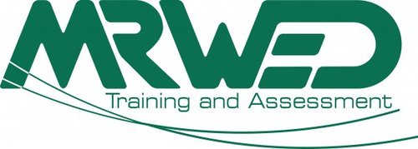

TAE40116
Certificate IV in Training and Assessment

___________________________________________________________________

eRPL UPGRADE
TAE40110 to TAE40116
INFORMATION PACK

version 3.0

___________________________________________________________________

FREECALL 1800 2 TRAIN (1800 2 87246)
PO Box 325, Caboolture QLD 4510
www.mrwed.edu.au



The eRPL Upgrade is specifically designed to only help people previously issued with some or all of
TAE40110 Certificate IV in Training and Assessment
and wish to upgrade to
TAE40116 Certificate IV in Training and Assessment.

If you have NOT previously obtained some or all of
TAE40110 Certificate IV in Training and Assessment
then you should not use this Information Pack.

If you have previously obtained
TAA40104 Certificate IV in Training and Assessment or
BSZ40198 Certificate IV in Assessment and Workplace Training, but you have not obtained some or all of
TAE40110 Certificate IV in Training and Assessment
then you should NOT participate in the eRPL Upgrade.

Contents

Contents 3
What is eRPL? 4
How does eRPL work? 5
What is TAE40116? 6
Mapping - Qualifications 7
Mapping – Units of Competency 8
Do I need to upgrade? 9
What Upgrade Evidence is Required? 10
What Professional Development Evidence is Required? 11
Is Help Available? 11
What is the Pricing? 12
Frequently Asked Questions 13

What is eRPL?

MRWED has been issuing qualifications in training and assessment since 2000 and we have assisted more than 25,000 students in obtaining nationally recognized training.

eRPL (electronic RPL) has been launched by MRWED based upon feedback from our RPL candidates who have consistently told us they want RPL that is:

EASY to understand,

SIMPLE to submit, and

FAST results.

eRPL allows you to upload your evidence instantly to our MRWED Learning Leaders using a specially customized MRWED Online course. The screenshot below shows the home page for the eRPL Upgrade course.

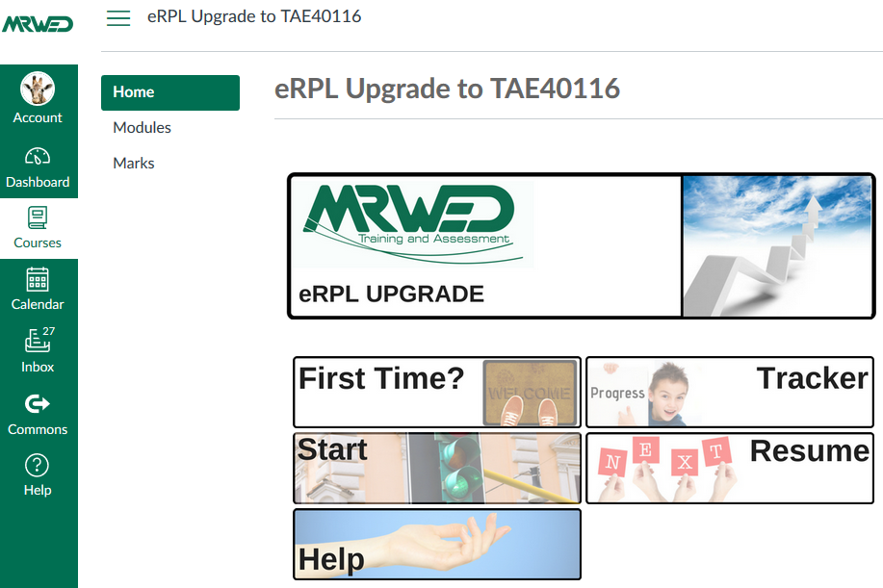

How does eRPL work?

You submit a TAE40116 Application to MRWED

You receive an email inviting you to choose your preferred time for an Application Interview with a MRWED team member
The Application Interview (normally less than 20 minutes) is conducted by phone to finalise compliance issues and answer all your questions
You receive a Learning Journey identifying your planned enrolment
You return your Course Acceptance Letter
Your enrolment is finalised, your invoice is issued, and you receive an email inviting you to login to your eRPL Upgrade course
You submit your RPL evidence
Your evidence is assessed
Your TAE40116 testamur and transcript are emailed to you

What is TAE40116?

The eRPL Upgrade provides an easier pathway for candidates who want to upgrade from TAE40110 Certificate IV in Training and Assessment to TAE40116 Certificate IV in Training and Assessment.

TAE40110 has been superseded by TAE40116. However, this may not mean you need to upgrade now. Please read the information on page 9 to help you decide whether you should upgrade at this time.

The eRPL Upgrade is only helpful to people who have previously obtained some or all of the required TAE40110 Units of Competency. If you did not obtain units from TAE40110, please contact MRWED on 1800 287 246 or visit www.mrwed.edu.au to view your options.

A comparison of the two qualifications reveals that:

- Both qualifications require a minimum of 10 Units of Competency.
- TAE40110 required the completion of 7 Core Units and at least 3 Elective Units
- TAE40116 requires the completion of 9 Core Units and at least 1 Elective Unit
- The 2 new Core Units are:
  - TAEASS502 Design and develop assessment tools
  - TAELLN411 Address adult language, literacy and numeracy skills
- The Unit TAEASS401B titled Plan assessment activities and processes has been superseded by TAEASS401 and the two Units are NOT equivalent due to increased assessment requirements of the new Unit.
- The Unit TAEASS403B titled Participate in assessment validation has been superseded by TAEASS403 and the two Units are NOT equivalent due to increased assessment requirements of the new Unit.
- Although assessment requirements may have changed, the other specified Units for the TAE40110 qualification have been identified as being equivalent to the Units that have superseded them.

Recognising the key points above, MRWED has created this Information Pack and the eRPL Upgrade to provide customised guidance for people who want to upgrade from TAE40110 to TAE40116.

To upgrade to TAE40116, due to the inclusion of two new Core Units of TAELLN411 and TAEASS502, you will be required to provide either:
- a statement of attainment demonstrating that you have already completed these units; OR
- a statement of attainment demonstrating you have completed the previous equivalent units; OR
- complete these Units through either RPL or a training and assessment pathway (which is not included in the eRPL Upgrade).

If you have not already achieved TAELLN411 and TAEASS502 MRWED provides options for RPL, Online and Face-to-Face training (supplemented by online learning activities and assessments). Contact MRWED for details or discuss this with our team member during your Application Interview.

Mapping - Qualifications

A comparison of the two qualifications reveals the following.

 | TAE40110 | TAE40116
Entry Requirements | None | Must have vocational background in  a proposed area of teaching
Course Outline | 10 Units (7 Core, 3 Electives) | 10 Units (9 Core, 1 Elective)
TAELLN411 | Elective | Core
TAEASS502 | Elective | Core

Mapping – Units of Competency

TAE40110 units | TAE40116 units | Equivalence
TAEASS301A | TAEASS301 | Equivalent - Updated to meet Standards for Training Packages.
BSBCMM401A | BSBCMM411 | Equivalent
TAEASS401B | TAEASS401 | Not equivalent - there is an increase in the amount of evidence that candidates need to provide for this unit. Updated to meet Standards for Training Packages.
TAEASS402B | TAEASS402 | Equivalent - Updated to meet Standards for Training Packages.
TAEASS403B | TAEASS403 | Not equivalent – there is an increase in the amount of evidence that candidates need to provide for this unit. Updated to meet Standards for Training Packages.
TAEASS502B | TAEASS502 | Equivalent - Updated to meet Standards for Training Packages.
TAEDEL301A | TAEDEL301 | Equivalent - Updated to meet Standards for Training Packages.
TAEDEL401A | TAEDEL401 | Equivalent - Updated to meet Standards for Training Packages.
TAEDEL402A | TAEDEL402 | Equivalent - Updated to meet Standards for Training Packages.
TAEDEL404A | TAEDEL404 | Equivalent - Updated to meet Standards for Training Packages.
TAEDES401A | TAEDES401 | Equivalent - Updated to meet Standards for Training Packages.
TAEDES402A | TAEDES402 | Equivalent - Updated to meet Standards for Training Packages.
TAELLN401A | TAELLN411 | Equivalent - Updated to meet Standards for Training Packages. Greater clarity provided in TAELLN411 on the nature of VET practitioner knowledge required.
TAETAS401A | TAETAS401 | Equivalent - Updated to meet Standards for Training Packages.

Do I need to upgrade?

The Hon. Karen Andrews MP, Assistant Minister for Vocational Education and Skills, released an amendment to the training and assessment credential requirements in the Standards for RTOs 2015, in July 2017. These were updated to align with the Training and Education (TAE) Training Package. The TAE Training Package was updated in April 2016, with the core units TAEASS502 Design and develop assessment tools and TAELLN411 Address adult language, literacy and numeracy skills being added to the new TAE40116 Certificate IV in Training and Assessment. The core units of the Assessor Skill Set were also updated to include the unit Design and develop assessment tools.
To ensure the VET workforce has appropriate skills in designing and developing assessment tools and identifying and evaluating LLN requirements, Skills Ministers have agreed to update the Standards to align with the changes to the TAE Training Package. Skills Ministers also agreed that trainers and assessors who do not hold the relevant units, have until 1 July 2019 to meet the new credential requirements.
This means your TAE40110 Certificate IV in Training and Assessment is still sufficient until 1 July 2019. However, trainers and assessors will need to obtain the two additional core units, if they want to use the Certificate IV in Training and Assessment to deliver and/or assess nationally recognised training beyond that date.
It should be noted that the Standards for RTOs continue to allow trainers and assessors who hold diploma or higher-level qualifications in adult education, to use those to meet their trainer/assessor credential requirements.
This being said, individuals who already possess the TAE40110 Certificate IV in Training and Assessment might want to upgrade now because they either:

- Need to upgrade, due to the specific, internal policies and guidelines of an RTO that they work for or might potentially want to work for in the future OR
- Want to benefit from the personal marketing advantages of holding the latest version of the qualification OR
- See this as a useful professional development process to keep themselves current OR
- Conclude that it might be a good time to upgrade now, in preference to potentially having to do this at a later time, when the upgrade process might be more difficult and/or expensive.

What Upgrade Evidence is Required?

The eRPL Upgrade course will help you collect and submit your upgrade evidence one step at a time, as shown in the following screenshot.

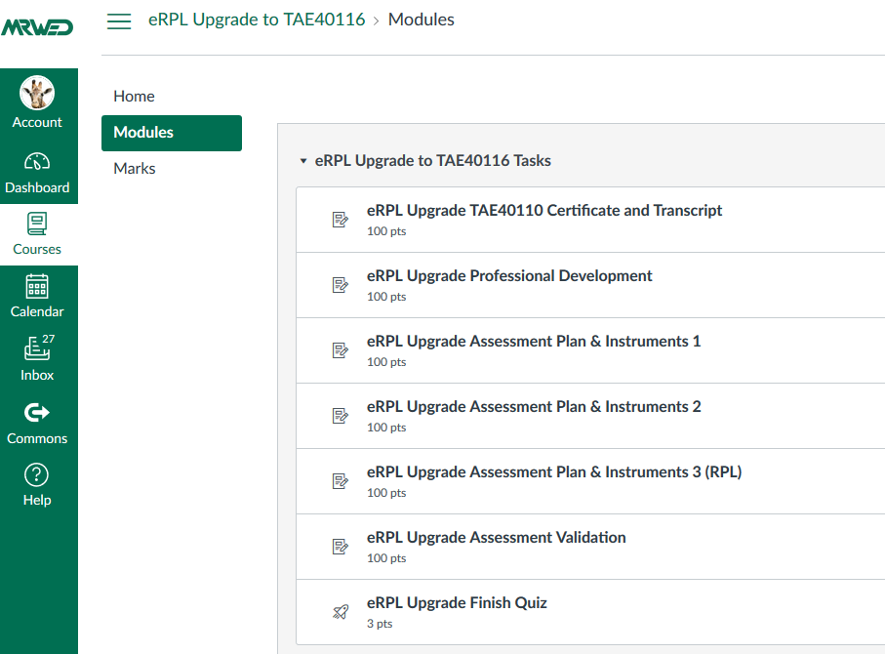

In summary, you will be required to provide:

- A copy of your TAE40110 qualification and transcript of Units;
- Evidence that you have participated in recent professional development to improve your skills as a trainer, assessor or learning designer;
- 3 assessment plans and associated instruments; AND,
- An assessment validation report.

If you are not currently working in a training organisation this is not a problem, as project options, including all the templates you need, are provided to all eRPL Upgrade candidates for optional use. You can however submit documents you have already created in your workplace as your upgrade evidence. The choices are yours.

What Professional Development Evidence is Required?

One of the assessment requirements is to provide evidence showing how you are maintaining your professional development as a VET trainer, assessor, RTO manager or learning designer.

Upgrade candidates need to provide evidence for AT LEAST ONE of the options shown in the below screenshot.

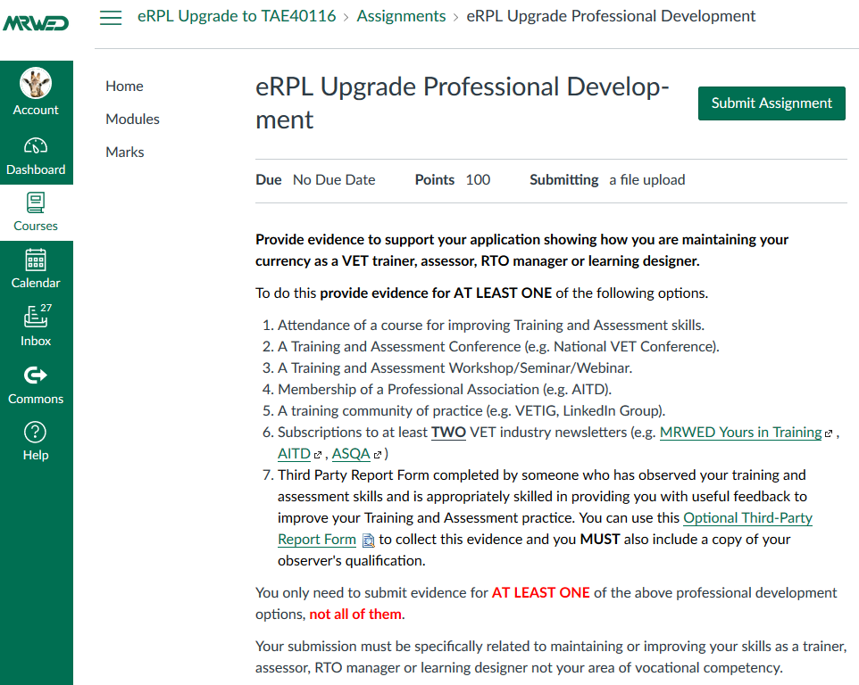

Is Help Available?

If your skills are a little rusty and you are unsure about developing assessment plans, assessment instruments or participating in an assessment validation this is not a problem, as the eRPL Upgrade course includes access to optional training at no extra charge. Our Learner Success Team is also available between 8:30am – 4:30 pm each Monday – Friday through the online “Help” option. Alternatively, you can ring them on FREECALL 1800 2 TRAIN (1800 287 246).

What is the Pricing?

The total price for participating in the TAE40110 to TAE40116 Upgrade, including all training and assessment fees is $400.00, or $380.00 for previous MRWED graduates. No additional fees are payable for recognizing your achievement of the other TAE40116 units through equivalent units you obtained during TAE40110.

Be aware however that Upgrade candidates cannot be issued with TAE40116 unless you have also completed TAE40110 and the two new Core Units of TAE40116, which are:
- TAELLN411 Address adult language, literacy and numeracy skills
- TAEASS502 Design and develop assessment tools.

If you need to also complete either or both new Core Units, then the following additional fees apply.

TAELLN411 Course Options
- Credit Transfer $0
- RPL $143.00
- Online $280.00
- Face-to-Face $280.00
(1-day workshop + online Learning Activities and assessments)

TAEASS502 Course Options
- Credit Transfer $0
- RPL $200.00
- Online $350.00
- Face-to-Face $350.00
(2-days workshop + online Learning Activities and Assessments)

In addition to any Units you are entitled to receive through the upgrade process, MRWED’s standard pricing will apply to any additional Units you choose to obtain.

Frequently Asked Questions

How do I get started?

Submit the application form and then you will receive an email describing your expected journey. Once you have accepted this journey you will receive access to MRWED online to submit your evidence.

When do I submit my evidence?

You can start collecting evidence at any time but do not provide any of the evidence to MRWED until you receive an email inviting you to login to your eRPL Upgrade course. This will happen after your enrolment is confirmed.

Once you receive your access to your eRPL course you can upload all of your evidence as quickly as you can.

How long does the assessment take?

Most eRPL Upgrade evidence is assessed within less than seven (7) days. It is not unusual for it to be assessed within 24 hours of your submission.

Can I be certain I will obtain the upgrade if I submit evidence for all of the required evidence items?

No. MRWED has developed the eRPL Upgrade to make applying for the upgraded qualification as easy as possible. However, your participation in the evidence check lists and projects that have been created as part of this kit will not guarantee your eligibility. Ultimately, your MRWED assessor is responsible for ensuring that the quality and diversity of the submitted evidence satisfies all the evidence requirements and meets each of the Rules of Evidence. Additional evidence may be requested by a MRWED Learning Leader to support your claim of current competency.

What happens if my application is unsuccessful?

If there is insufficient evidence to complete your upgrade a MRWED assessor will advise you of the specific gaps in your evidence. If you are unable to provide the necessary evidence, the MRWED Learning Leader will discuss alternative training options with you. If you are unsuccessful with your eRPL Upgrade then you will not be charged any fee for the eRPL Upgrade. If you have already paid you will receive a full refund for the costs of the eRPL Upgrade.

Do I need specialist computer skills or software to participate in the eRPL Upgrade?

No, however you will need access to a computer or device with access to the Internet to download templates and upload evidence submissions. If you are familiar with accessing and navigating websites and downloading documents then you are well prepared for participating in the eRPL Upgrade. If you have concerns about your computer literacy then please discuss this during the Application Interview.

If eRPL is not a good fit for you then contact MRWED as we can provide to you a MRWED TAE40110 to TAE40116 Upgrade Kit that enables you to participate in the upgrade without needing to use the eRPL Upgrade site. The pricing is identical, but assessment times are substantially longer.

Will I need to provide any original or hard-copy RPL evidence?

No! By participating in the eRPL Upgrade you will not need to send any original or hard copy documents to MRWED. There will be no mail delays in processing your application. If required, the MRWED Learner Success Team member who reviews your submission may contact you for further information or assistance in the verification of your documents.

Where do I submit my application?

Please submit the Application Form on the following pages either through:

- Email: clientrelations@mrwed.edu.au
- Post: PO Box 325 Caboolture QLD 4510

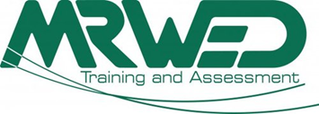
Application Form
Section 1: Proposed Student Details
*Student name and DOB on application must match the Unique Student Identifier*

*Student’s Last Name: | *Student’s First Name:  Student’s Middle Name:
*Student’s Gender:  ☐ Female ☐ Male | *Student’s Date of Birth  ______/______/______
*Student Email Address:

Unique Student Identifier  If you have an existing USI please enter below. If not, you will receive further instructions upon receipt of application or visit www.usi.gov.au  USI: | *Student Contact Phone:  Home:  Mobile:  Work:
*Student’s Residential address  Unit/Flat #________Street/Lot #________  Street Name________________________  Suburb_____________________________  Post Code___________ State___________  Country____________________________ | Student’s Postal Address (If different from residential)  Unit/Flat #_______Street/Lot #___________  Street Name / PO Box# __________________  Suburb_______________________________  Post Code___________ State_____________  Country______________________________

Section 2a: Employment
*Of the following categories, which BEST describes your current employment status?
☐ Full time employee
☐ Part – time employee
☐ Self-employed not employing others
☐ Employer
☐ Employed – unpaid worker in a family business
☐ Unemployed – seeking full time work
☐ Unemployed seeking part-time work
☐ Not employed – not seeking employment

Section 2b: Language and cultural diversity
*What is your country of birth? | *What is your Nationality?
*What is your town of birth? | *What is your Nationality?
*What is your main language?  ☐ English  ☐ Other – Please specify:_____________ | *How well do you speak English
  ☐ Well | ☐ Poorly
  ☐ Very Well | ☐ Not well
*What is your Citizenship Status?  ☐ Australian Citizen  ☐ New Zealand Citizen  ☐ Permanent humanitarian Visa Holder  ☐ None of the above | *Do you identify as being of Aboriginal or Torres Strait Islander origin?  ☐ No  ☐ Yes, Aboriginal  ☐ Yes, Torres Strait Islander

Section 2c: Schooling
*Are you still attending school?  ☐ No  ☐ Yes  *If no, what year did you complete school?  E.g. 1980 ___________________________________ | *What was the highest COMPLETED level of schooling?  ☐ Year 12 or equivalent  ☐ Year 11 or equivalent  ☐ Year 10 or equivalent  ☐ Year 9 or equivalent  ☐ Year 8 or below  ☐ Did not attend school

Section 2d: Disability
*Do you consider yourself to have a disability, impairment or a long-term health condition?  ☐ No – Go to section 2e  ☐ Yes – Complete section 2d in full  *Will you require extra assistance to undertake your course with MRWED?  ☐ No  ☐ Yes – A MRWED team member will be in contact with you to discuss any additional requirements. | If yes, please indicate the areas of disability, impairment or long-term health conditions:  ☐ Hearing/Deaf ☐ Mental illness  ☐ Physical ☐ Acquired brain impairment  ☐ Intellectual ☐ Vision  ☐ Learning ☐ Medical condition  ☐ Other: (please specify)

Section 2e: Previous qualifications achieved
*Have you successfully completed any of the following qualifications?
☐ No – Go to section 2f ☐ Yes – Complete below

AQ = Australian Qualification AE = Australian Equivalent I = International
Select qualification and which standard it applies to  ☐ Bachelor degree or higher  ☐ Advanced Diploma or associate degree  ☐ Diploma or associate diploma  ☐ Cert IV or advanced certificate/technician  ☐ Cert III or trade certificate  ☐ Cert II  ☐ Cert I  ☐ Certificate other than above | AQ  ☐  ☐  ☐  ☐  ☐  ☐  ☐  ☐ | AE  ☐  ☐  ☐  ☐  ☐  ☐  ☐  ☐ | I  ☐  ☐  ☐  ☐  ☐  ☐  ☐  ☐

Section 2f: Study reason
*Of the following categories, which BEST describes your main reason for undertaking this course?

☐ To get a job ☐ It was a requirement of my job
☐ To develop my existing business ☐ I wanted extra skills for my job
☐ To start my own business ☐ To get into another course of study
☐ To try for a different career ☐ For personal interest or self-development
☐ To get a better job or promotion ☐ Other reasons, please explain:

Section 3 – Application Follow Up Information if required
Once this application has been reviewed, a MRWED mentor may contact you to discuss a tailored learning journey. What is the best way for the MRWED mentor to contact you?

Please call me on phone number:

Please email me at:

Other communication – please specify:

If there is any other information, relevant to contacting you regarding this application,
please let us know here:

Section 4 - Language Literacy and Numeracy (LLN)
MRWED Training and Assessment is committed to supporting all our students in successfully completing their selected course of study. National research consistently indicates that many students will require some level of LLN support. As such, we recognise that we have a responsibility to understand each student’s unique LLN needs.

Our desire is to identify any LLN need that you may have as a student and to assist you in reducing the impact this may have on your studies with MRWED. Therefore, we ask for you to either opt in or opt out of an LLN assessment, which will help us to determining how best to assist you. Please select one of the following two options.

☐ - I appreciate that MRWED is interested in my LLN capabilities, however I affirm that I do not require any assistance with LLN for the course I am choosing to undertake.

☐ - I am unsure if my LLN capabilities are sufficient for the level of study I am undertaking; therefore, I elect to submit the completed LLN assessment to MRWED for assessment.

Section 5 - Entry Requirements
All candidates looking to complete the Certificate IV in Training and Assessment must be aware that this qualification has an entry requirement. The requirement states:

Those entering this program must be able to demonstrate vocational competency in their proposed teaching and assessing area. Vocational competency is defined as broad industry knowledge and experience, and may include, but is not limited to, holding a relevant unit of competency or qualification.

Based on this entry requirement, we require that you provide information on the following:

A: Briefly describe your vocational experience relating to the area that you wish to train and assess. (e.g. I am a chef by trade and wish to train and assess hospitality and commercial cooking)

B: Please list any unit/s of competency or qualifications/s that you currently hold which you intend to train and/or assess. (e.g. Certificate III in Commercial Cookery)

I confirm that my responses to questions A and B above will be the area/s in which I intend to use my Certificate IV in Training and Assessment once obtained.

☐ YES ☐ NO

You must provide MRWED with evidence of this vocational competence. To fast track your application please attach your vocational competence evidence with this application. If you are unsure of what evidence to provide or are unable to attach a copy to this application, please contact us for advice.

Section 6: Study options

Please indicate your preferred study options below:

TAELLN411 | CT Online Correspondence Face to face
TAEASS502 | CT Online Correspondence Face to face
Unit How are you going to complete these units?

If the student intends to complete some or all of the course through face-to-face training, then please indicate the course locations and date preferences below.

Available dates can be viewed here: https://www.mrwed.edu.au/timetable

TAELLN411 | ___/___/___
TAEASS502 | ___/___/___
Unit Start Date Brisbane Sydney Melbourne Adelaide Custom
Section 7: Applicant Declaration
I declare that all information provided within this application form is true and correct.

Applicant’s Signature:

You can submit this form by:
- Free fax 1800 333 082 or
- Email to clientrelations@mrwed.edu.au or
- Post to MRWED, P.O. Box 325, Caboolture, QLD 4510.

