**The Trainer’s play Book**

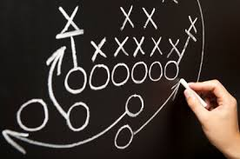

**Connecting the sports field with the classroom**



# Preparation

*Any successful sports person will tell you that preparation is as important as the game. In sport we practice, accept coaching and refine our skills. We study other players that are having success at the level we are looking to achieve and look for techniques we can replicate. In being a successful presenter we should follow the same path.*



# 7 steps to developing a session plan

* Set a clear ____________ using verbs.
* Break your _______________ down into bite sized chunks.
* Consider the best _______________ for your topic.
* Choose an appropriate _______________ of _______________.
* How will _______________ impact the session?
* Organise the Resources you will need for this session.
* What _______________ do you need to collect?

**Discussion:** What tips can you share to improve preparation?

# Warm up

**🗮**

**Example of a warm up activity: Know your Team.**

*Give a single piece of flip chart paper, coloured markers and some blue tack to each table. Ask them as a team to draw a circle that covers a majority of the page. Give your audience a few minutes to discover 3 things they all have in common and write these inside the circle. Outside the circle, ask them write their names and find 1 thing each that makes them unique. Once complete, have each team stick their poster up on the wall then introduce the members, what this team shares in common and what makes each person unique.*

# 6 keys to developing meaningful warm up activities

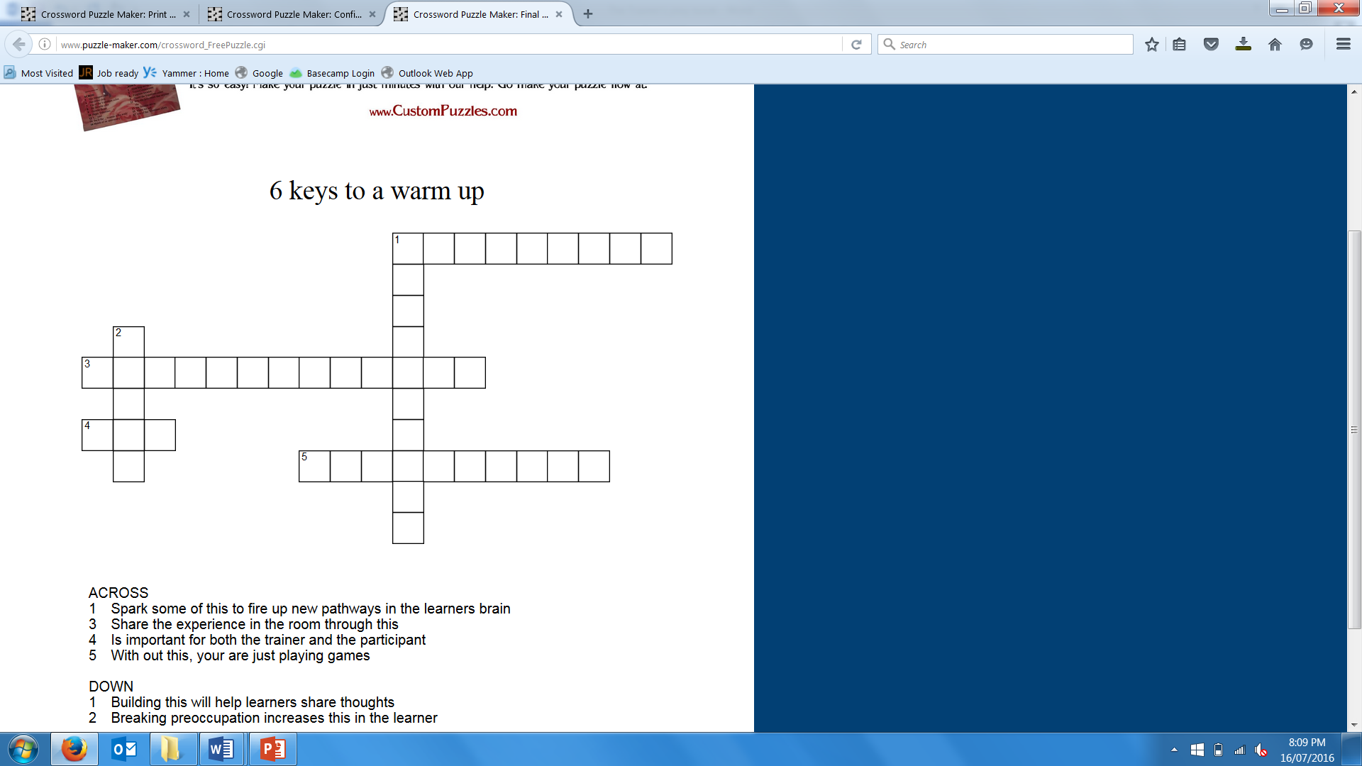

Source: <http://www.puzzle-maker.com>

**Discussion:** Share an example of a warm up activity you have enjoyed.

# Performance

*Being an engaging presenter is part educator and part entertainer. Have you even been to a training session that made you think “that session was so boring”, however the content was great? This is often the case when a subject matter expert has a lot of experience with the subject and can even amaze you with their knowledge, but lacks the performance skills necessary to engage the audience in the learning. Research tells us that learner engagement plays an extremely important part in improving retention.*



# 5 tips to improve your performance

* Be ______________ not ______________.
* Keep ______________ in motion.
* Ask good ______________.
* Vary your______________, pitch and______________.
* Energy is contagious, but so is boredom.

**Discussion:** What could you do to make a presentation more memorable?

# Cool down

*In sporting terms, the cool down is an important part of the athlete’s process. It allows them to reduce injuries, reflect on their performance and to start formulating a plan for improvement. Often coaches take this opportunity to discuss observations whilst it is still fresh in the athletes mind and to re-inforce areas of good performance. In the learning environment, closing a session is a golden opportunity to help the learners move information from their short term memory to long term memory and improve the transfer of the learning back to the job.*

# 4 rules to developing closing activities.

* Create activities that encourage leaners to _________________.
* Make ___________ for learners to __________ the key messages.
* Encourage learners to ______________ their journey.
* Create opportunities to link the learning to life.

**Discussion:** What are your gold, silver and bronze ideas?